Fields and Forage Alliance
- Organizational overview
  - Mission statement: Empowering and educating Minnesota communities through regenerative land management practices. Together, we can enhance soil health, protect water resources, and promote biodiversity; all to ensure a more sustainable future.
  - Brief overview of your organization’s history, purpose, activities and program areas:
    - History and Purpose: Fields and Forest Alliance (FFA) was founded in 2020 with a vision to promote ecological restoration through community engagement in Minnesota. Since then, FFA has grown into a dynamic non-profit committed to community-led, sustainable land management. The purpose of FFA is Ecological Restoration, Community Engagement, and Soil and Water Health.
    - Activities: Through land acquisition, we utilize a network of volunteers to plant native species, maintain food forests, and manage the continual prairie restorations as needed. Volunteers, paid advocates, and partners will lead and host workshops and educational visits. Volunteers will also raise awareness about regenerative land practices. Partnerships with indigenous communities will educate the public on their traditional ecological knowledge and the importance of community and cooperation.
    - Program Areas:
      - Prairie Restoration: Focused on restoring native grasslands and wildflower habitats.
      - Food Forests: Creating edible landscapes that benefit both people and the environment. Partnering with local food shelves to donate nutritional, locally grown food.
      - Indigenous Partnerships: Collaborating with tribal leaders and educators as well as Indigenous-lead non-profit organizations to honor ancestral connections to the land.
  - Key accomplishments:
    - Land Restoration: Restored 40 acres of degraded and abandoned agricultural fields at four project sites, enhancing biodiversity and supporting native plant species.
    - Community Engagement:
      - Engaged 25 volunteers per site in planting and maintaining food forests and native prairies, and leading educational efforts, fostering community ownership.
      - Conducted 10 educational workshops and tours per site per year, reaching over 1,200 Minnesota residents annually.
    - Indigenous Partnerships:
      - Collaborated with tribal leaders to incorporate traditional ecological knowledge into restoration practices.
      - Honored ancestral connections by planting culturally significant species.
    - Soil and Water Health:
      - Improved soil health in 40 acres through rebuilding native prairie lands and community food forests.
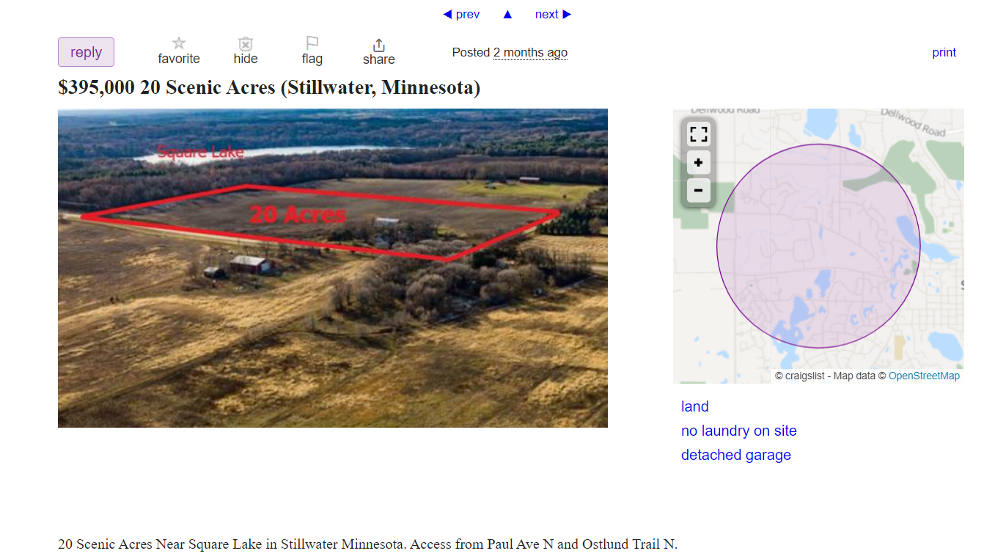
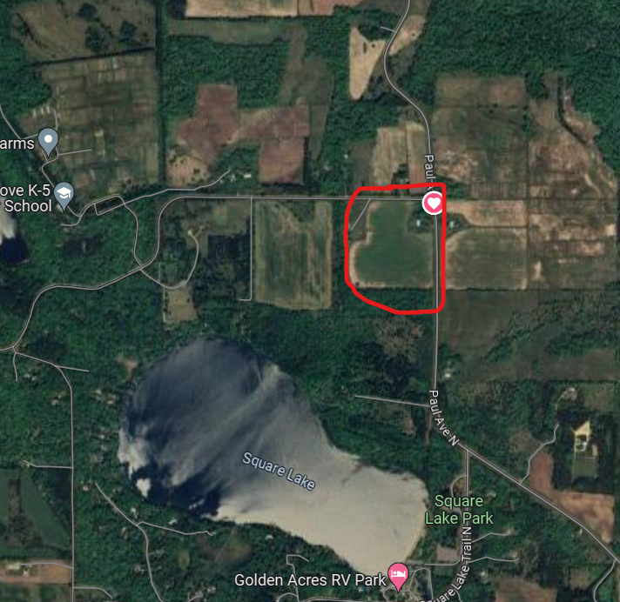
      - Monitored water quality in restored areas, demonstrating positive impacts that prairie and food forest can provide and by sequestering and diverting neighboring lands negative impact outputs before heading to local watersheds and Drinking Water Supply Management Areas.
Site Maps – Google Maps and Craigslist
- Project Overview
  - Project Name: Field and Forage Alliance - Stillwater (FFA-S)
  - Need/Purpose: We are seeing overwhelming evidence of our disappearing prairies in Minnesota: “Prairie habitats once covered one-third of Minnesota but presently less than two percent remains.” ^{[1]} Prairies are vital ecosystems that provide immeasurable biodiversity, water, and soil health. Conventional agriculture is a threat to the existence of prairies, depleting natural resources and polluting our waters and degrading our soils. The purpose of this project is to incentivize communities to consider transitioning portions of land back to native prairies and foster a sense of responsibility in land stewardship.
  - Overview of project geography: The FFA-S project is located on 20 Acres in Stillwater, Minnesota. This land is adjacent to agricultural use land and is near the local watershed and recreational water.
  - Project goals:
    - Ecological Restoration: Restore native prairie areas by seeding and planting native grasses, wildflowers, forbs, and sedges and restore native and edible tree, perennial, and shrub varieties in the community food forest areas.
    - Community Engagement: Engage volunteers in board membership, planting, maintenance, and educational activities. Educate and engage the public in responsible, sustainable, environmental stewardship.
    - Indigenous collaboration: Partner with indigenous leaders to honor ancestral connections and incorporate traditional ecological knowledge into land management.
    - Improve soil and water health.
  - Specific activities you will undertake to achieve those goals
    - Land Acquisition: Identify suitable land and acquire through funding.
    - Planting and Maintenance: Organize volunteer planting events for native prairie species and food forest and maintain food forests by pruning, weeding, and watering.
    - Educational Opportunities: Host workshops and educate the community about our mission.
    - Indigenous Knowledge:
      - Collaborate with indigenous leaders to learn and integrate traditional ecological knowledge throughout implementation.
      - Conduct joint workshops and storytelling sessions.
    - Monitoring: Regularly assess plant growth, soil quality, and water health.
  - Project deliverables
    - Restored acreage from traditional agriculture to healthy prairie and woods
    - Monitoring Data
    - Educational Reports
    - Progress Reports with Stakeholders
  - Expected outcomes (e.g. anticipated impact on habitat and water quality)
    - Ecological Restoration
    - Community Involvement
    - Indigenous Collaboration
    - Increased Biodiversity
    - Improved soil and water health
- Project partners and stakeholders
  - For this project to be a success, ideal partners for this project are:
    - Stillwater Chamber of Commerce
    - Minnesota Soil Health Coalition
    - Washington Conservation District
    - Sustainable Stillwater: A local group with access to volunteers and resources
    - University of Minnesota Extension: They can offer valuable information, piggy-back on their already extensive media following.
    - Wild Rivers Conservation: Another group with access to volunteers and resources, especially environmental data
    - Brown Creek Watershed Action Committee: A group of volunteers who actively engage and promote in local environmental programs
    - Prairie Restorations: A local nursery with an extensive resource list, potential donator of plant materials
  - Stakeholders for this project:
    - Twin Cities Metro Community, specifically Stillwater: Access to recreation and foraging, an environmental learning area
    - Educational Resource for Grade Schools and Universities: Use for fieldtrips and case studies, allow students to submit project applications
    - Local indigenous community leaders and groups: An area dedicated to their knowledge and wisdom
    - Local government: Increase in tourism in an already environmentally friendly community
    - Local businesses: Newspaper stories, increase in tourism
  - The ideal volunteer base for this project would consist of:
  - At least one representative from local non-profit environment organizations:
    - Wild Rivers Conservation
    - Sustainable Stillwater
    - Brown Creek Watershed Citizens Action Committee
    - Prairie Restoration
    - Dakota Wihocan
    - Local indigenous groups (Ojibwe and Dakota land)
  - Community Involvement with abilities in:
    - Marketing, promotion, communications
    - Grant-writing
    - Policy
    - Landscaping/Gardening
    - Treasury/Accounting
    - Administrative Support
  - Paid advisors in this project: At least one representative from the following groups or organizations who could provide specialized content and guidance on occasion:
    - University of Minnesota Extension
    - Minnesota Native Landscapes
    - Dakota Wihocan
    - We are Still Here Minnesota
- Project context
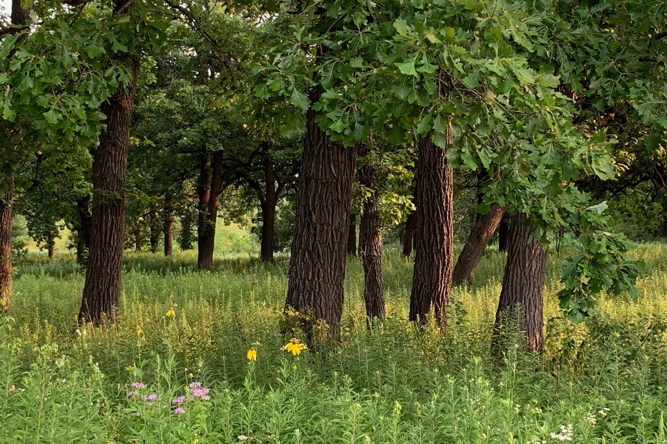
  - The FFA-S will be the fifth project, identical in practice and purpose, under FFA’s jurisdiction in Minnesota. FFA also has locations in Mankato (FFA-M), Alexandria (FFA-A), and Red Wing (FFA-RW). Each location must meet several requirements: it must be within 20 minutes of a city of over 15,000 residents and be located in one of the central prairie areas of Minnesota that acts as an agricultural hub for corn, soy, wheat, and grazing.

Coldwater Spring National Park – Southview Design
- Project timeline
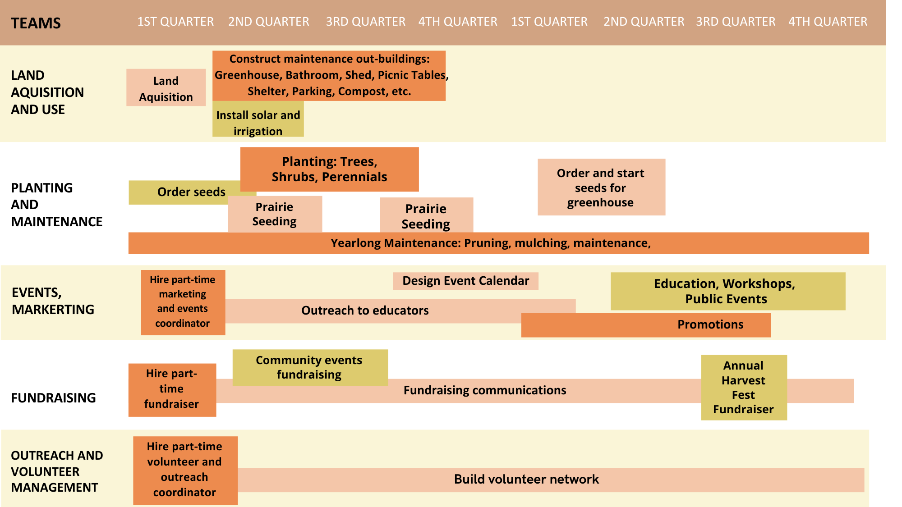
- Funding
  - Have matching or other funds been secured to support this project? If so, please identify sources and amounts of funding.
Donor | Item | Cost | Comment
Prairie Restorations | Shrubs, Trees, Prairie Seeds, Edible Perennials, Donation | Plants: $5,000  Donation: $1,500 | Prairie Restoration Path Acknowledgement through prairie
Site One Landscaping | Hardscape donation, general donation | Hardscape: $8,000  Donation: $5,000 | Acknowledgement at parking lot
Landscape Alternatives | Plant Donation | $2,000 | Acknowledgement: bench plaque
Abrahamson’s Nurseries | Tree, shrub and perennial donation, general donation | Plants: $5,000  Donation: $10,000 | Acknowledgement signage in food forest
Willow River Company | Trees and General Donation | Trees: $4,000  Donation: $5,000 | Acknowledgement in food forest
Good Earth Gardens | Plants and general donation | Plants: $2,000  Donation: $2,000 | Acknowledgement: bench plaque
Urban Eggplant Garden Supply | Perennials, mushrooms, and general donation | Perennials and mushrooms: $1,500  Donation: $5,000 | Sponsor at selfie station
Lunseth Organic Lawns | General donation | $5,000 | Acknowledgement in wildflower area
Twin Cities Seed Company | Prairie Seed and General Donation | Seed: $5,000  Donation: $5,000 | Acknowledgement in wildflower area
Kinnickinnic Gardens | Trees and general donation | Trees: $2,000  Donation: $5,000 | Acknowledgement in food forest
Tangletown Gardens | Shrub and flower donation | Plants: $2,000 | Acknowledgement: bench plaque
Sustainable Stillwater | General donation | $5,000 | Acknowledgement: Community Garden Signage
Washington Conservation District | General Donation | $20,000 | Acknowledgement: Solar power sponsor
University of Minnesota | General Donation | $20,000 | Acknowledgement: Outbuilding sponsor
Minnesota Soil Health Coalition | General Donation | $40,000 | Acknowledgement: Learning pavilion sponsor
Stillwater Chamber of Commerce | General Donation | $15,000 | Acknowledgement: Utilities Sponsor
Southview Design | Patio supplies and General Donation | Plants: $1,000  Donation: $7,000 | Acknowledgement:  Electric vehicle station sponsor
Biota Landscapes | General Donation | $5,000 | Acknowledgement: bench plaque
Public Donations above $1,000 | General Donation | $20,000 | Acknowledgement:  Tree Plaque
Public Donations above $100 | General Donation | $5,000 | Acknowledgement: brick paver
Minnesota Department of Natural Resources | Conservation Partners Legacy Grant Program | $45,000 | Acknowledgement: Prairie overlook patio sponsor
Total General Donations/Grants: $225,000 |  | Total Supplies and Materials: $37,500
After down payment ($100,000) on land: $125,000
  - Will the project move forward if you are unable to secure all the necessary funding?
    - The first few years are essential for raising funds. Once plant materials are established and producing, income for on-site events will significantly increase. After initial buildings are built, there will be a 90% decrease from year 1 to year 3. In the case of not securing funding in these crucial years, we will ask for volunteers in lieu of paid staff or significantly cut back on hours needed annually. Additionally, we can reduce our marketing/promotions budget as well as delaying several non-crucial buildings. Lastly, we could refinance our 10-year loan to a 30-year loan to reduce loan costs.

Organization: Field and Forage Alliance | Project: Field and Forest Alliance- Stillwater
Project Period: Jan 2025 - Dec 2026 | Jan 2025-Dec 2025 | Jan 2026-Dec 2026
 | 12 mo | 12 mo | 24 mo
 | Year 1 | Year 2 | Total
10-Year Land Acquisition Loan | $30,000 | $30,000 | $60,000
Property Taxes | $10,000 | $10,000 | $20,000
Wages (office) | $60,000 | $60,000 | $120,000
Wages (advisors) | $10,000 | $10,000 | $20,000
Utilities, Building and Upkeep | $25,000 | $4,000 | $29,000
Materials and Supplies | $0 (donated) | $0 (donated) | $0
Marketing and Promotions | $10,000 | $10,000 | $20,000
Insurance | $5,000 | $5,000 | $10,000
Other secured funding: | +$62,500 | +$62,500 | +$125,000
Projected On-Site Income: | +$8,000 | +$25,000 | +$33,000
Projected New Donations: | +$10,000 | +$10,000 | +$20,000
Total Program Expenditures Remainders: | $36,500 | $31,500 | $68,000
  - Budget Summary:

- Permits and Approvals
  - Land acquisition will be on private property listed as a community garden. County zone change from agriculture to private property is completed.
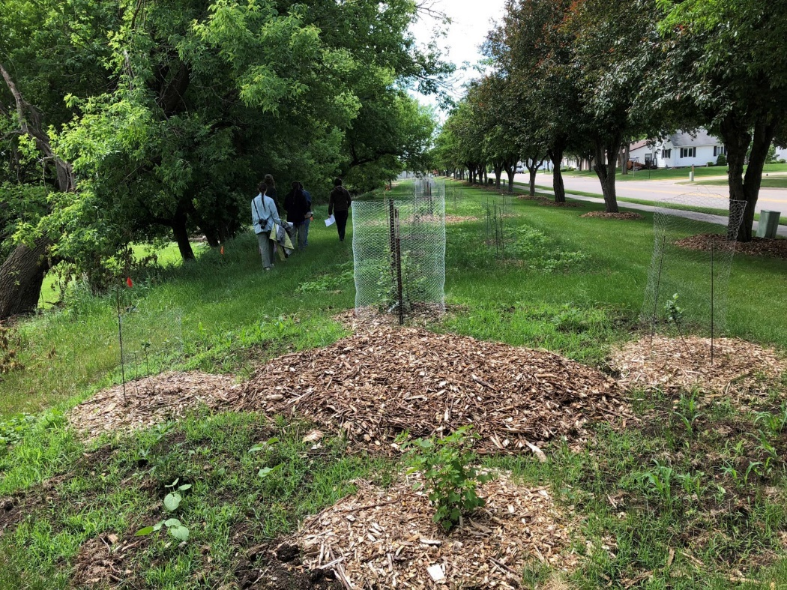

Food Forest in Luverne, MN – UMN Extension
- Project Challenges
  - Land Acquisition and Zoning: Complexities of purchasing agricultural land and ensuring zoning approval on land.
  - Volunteer Recruitment: Retention and attraction of committed volunteers
  - Community Support: Garner healthy involvement and reduction of public skepticism.
  - Long-Term Funding Opportunities: Ensuring the diversity of funding resources
  - Indigenous Collaboration: Ensure trust-building with meaningful partnerships, which takes time and consideration as well as equitable collaboration and honoring of cultural practices.
- Project evaluation
  - Ecological Metrics:
    - Monitor plant and animal diversity in both prairie and forest
    - Monitor soil health in restored areas
    - Measure changes in carbon sequestration and water quality
  - Community Engagement:
    - Track volunteer participation and community events.
  - Impact on Indigenous Communities:
    - Document knowledge-sharing and mutual learning.
  - Long-Term Sustainability:
    - Evaluate financial stability and funding diversification.
- Outreach
  - Outreach methods include:
    - Booth presence at Minnesota events
    - Hosting an annual Harvest Fest Fundraiser
    - Hiring a Volunteer and Outreach Coordinator to explore new businesses, schools, and organizations that have interest in the project and its programs.
    - Work with project partners to utilize media outlets on spreading the word and posting about volunteer opportunities

- Sustainability
  - The grant funding provided for this project will be utilized for initial, one-time, large expenses, such as the land acquisition costs.
  - We will rely on our staff and volunteers and fundraising efforts to continue seeking funding opportunities.
  - Income from educational trips, workshops, community garden memberships, tours, fundraising events, and more will be instrumental in the ongoing funding.

- Capacity to conduct project
  - Volunteer Board Members will lead the initial charge in program development, site development, grant-funding and fundraising efforts.
  - Three part-time employees will be utilized 20 hours per week:
    - Marketing and Events Coordinator
    - Fundraising Coordinator
    - Outreach and Volunteer Coordinator
  - Work with a group of 20-40 dedicated, committed volunteers

References

- “Benefits of Native Plants: Water Pollution Prevention.” Mississippi Watershed Management Organization, 2024,
- “Bosse, Kim, et al. “Community Gardens on Private Property as a By-Right or Permitted Use.” Sustainable Development Code, 2024, sustainablecitycode.org/brief/community-gardens-on-private-property-as-a-by-right-or-permitted-use. Accessed 26 June 2024.”
- “Conservation Partners Legacy Grant Program” Minnesota Department of Natural Resources. https://www.dnr.state.mn.us/grants/habitat/cpl/index.html
- “Guides to Prairie Restoration in Minnesota.” The Nature Conservancy, 2018,
- “Housing Search in Minneapolis.” Craigslist, n.d.,
- “Land and Water Legacy Program.” Washington County, MN, n.d.,
- “Native Grasses Benefit Butterflies and Moths.” University of Minnesota, n.d.,
- “New and Beginning Farmers.” US Forest Service, 2022,
- “Planting a Community Food Forest.” University of Minnesota Extension, 2022,
- “State of the St. Croix River Report.” Wild Rivers Conservancy, 2020,
- “Sustainable Agriculture.” Washington Conservation District, n.d.,
- “Turning Back Time: Restoring Saint Paul’s Historic Prairies.” Conservation Corps Minnesota & Iowa, 2015,
- “Understanding Water Quality Stresses and Recent Trends in the St. Croix River Watershed.” International Joint Commission, 2022,
- “WHAF Context Report - Major Watershed 37.” Minnesota Department of Natural Resources, n.d.,
- McKinney, Matt. “Along the St. Croix River, Big Ag Plans Prompt Water Quality Worries, New Restrictions.” Star Tribune, 2024,
- Shepard, M. (2013). Restoration agriculture: real-world permaculture for farmers. Austin, Tex., Acres U.S.A

