Multiple Site Location Analysis: Abundance and Diversity of
Pelagic Macroinvertebrates in Minnesota Lakes
4/21/2024
Report One: Scientific Peers
In this project, we are analyzing provided data to determine the abundance of five taxonomic groups over time. Our primary goal is to determine if there will be sufficient food quality (shown through growth or consistency in abundance) for other organisms or if new management options need to be implemented.
Results
Through Figure 1 and Figure 2, we will explain our findings.
Figure 1
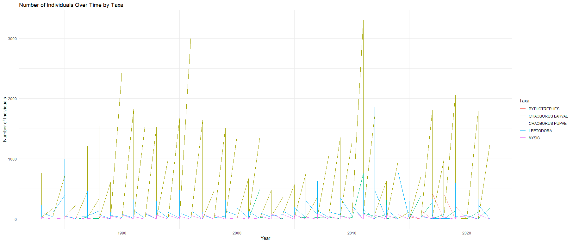
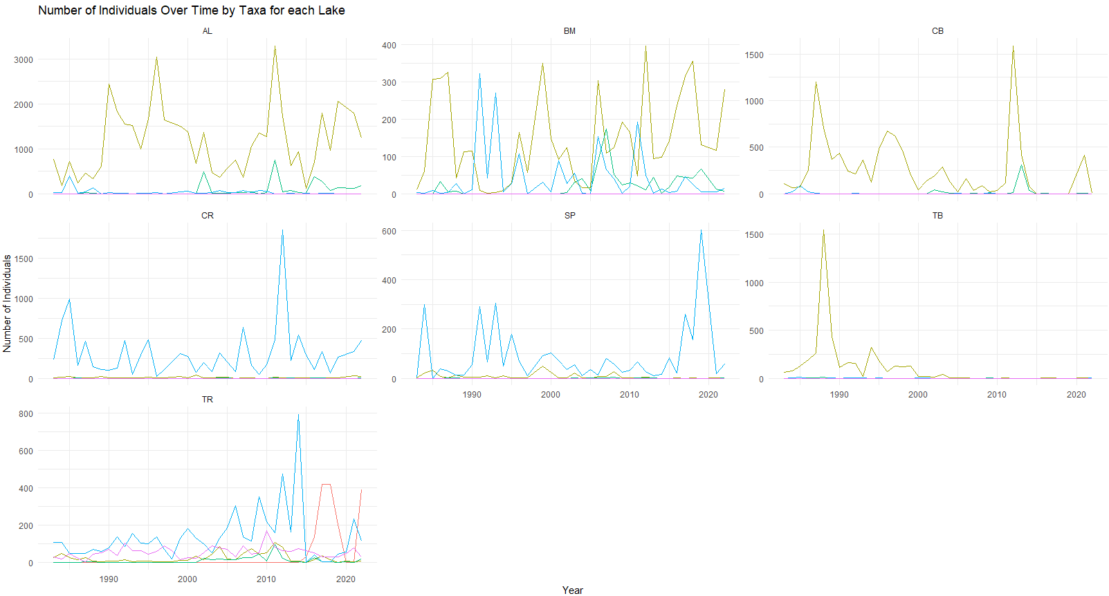
Year
Number of Individuals
Number of Individuals Over Time by Taxa for Each Lake
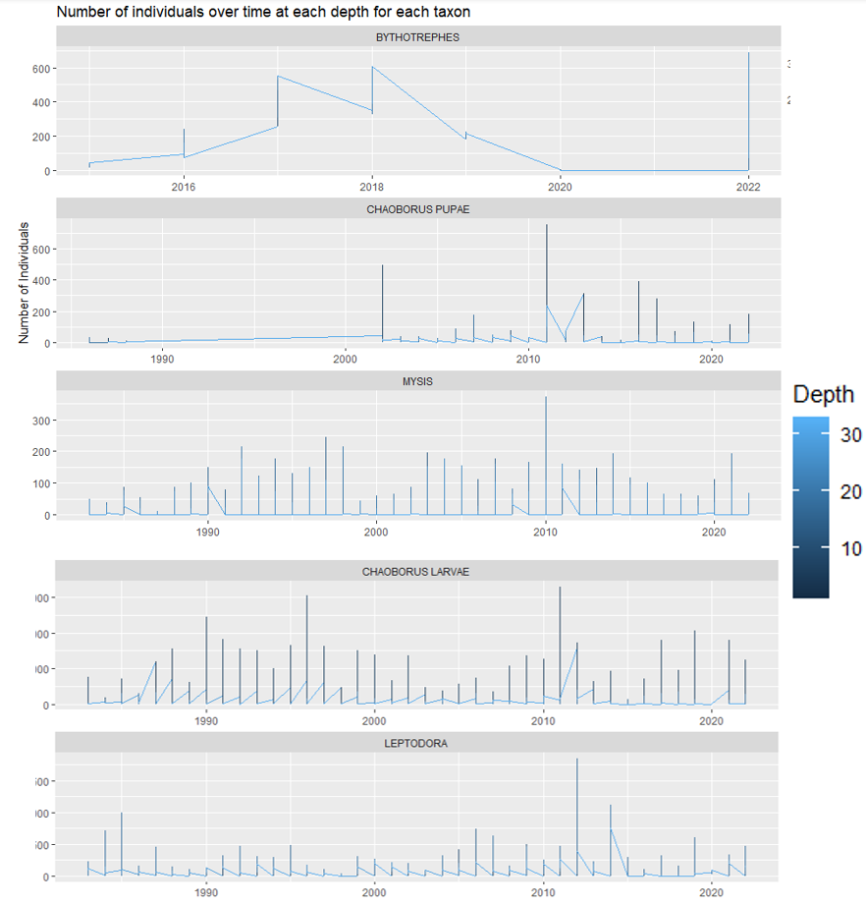
These figures show the population of each taxon between 1983-2022, for each lake in Figure 1 and for each depth in Figure 2. We will list key points based on their relevancy for answering our main questions:
Number of Individuals Over Time at Each Depth for Each Taxon

Figure 2
- In the Lakes where Chaoborus (both in its Larvae and Pupae life stage) is found, they have the most abundance over the rest of the taxon. In the lakes they are not found, Leptodora is the most abundant.
- In Trout Lake, we can see steady growth of all taxa until the introduction of Bythotrephes in 2001/2002. After introduction, all taxon populations rapidly decline. Once we see the decline of Bythotrephes, the introduced predator, we see abundance returning in all taxon again.
- An event in 2019 creates a spike in abundance increase in all lakes but the Trout Bog.
- The most common depth for all taxon except Bythotrephes is 0-15 feet, whereas Bythotrephes is 20-30+ feet.
Discussion
We are looking at a group of taxa who typically live at 0-15 feet, except for Bythotrephes, who is found at lower depths. Once introduced, Bythotrephes outcompetes with the rest of the taxon, which significantly reduces the abundance of all other taxon.
It’s clear that the introduction of an invasive species is our main issue. If we consistently see the other four taxon in a never-ending cycle with Bythotrephes, or if Bythotrephes becomes the primary and singular taxon in these sites, we will see a decline in fish and other organisms that rely on the diversity of these observed taxa.
As we are just seeing the first cycles of this scenario play out, more data on Bythotrephes in the future will be extremely important in reducing our uncertainty going forward. We can surmise that sites without Bythotrephes will have a higher abundance of the other taxa in each lake.
Reflection
Through this report, we have chosen to take a closer look at the abundance of different Pelagic Macroinvertebrates by comparing site locations and depth of habitat. Through the figures we were able to see trends that indicate an introduction of an invasive species. Further sampling is necessary to determine the long-term changes this new species has on its surroundings. If proven to out-compete and create an imbalance of food quality for other organisms. This would directly affect biodiversity and recreation at each site.

Report Two: Public
Pelagic Macroinvertebrates have an important role to play in your local lake. All the wildlife you enjoy seeing and the fish you enjoy catching are a part of their ecosystem. Fish, birds, amphibians and reptiles all depend on this group for food. The abundance or absence of certain species dictate the health of a body of water.
We have collected data on the abundance of specific pelagic macroinvertebrates at different depths at different lakes. We want find out more information about their habitats as well as the differences each site can tell us about their local diversity.
Figure 1
Year
Number of Individuals
Figure 2
Number of Individuals Over Time at Each Depth for Each Taxon

Results
We can see in Figure 1 that the invasive species, Bythotrephes (known as the spiny waterflea), is introduced in 2001 in Trout Lake. All other sites are free from the spiny waterflea.
We can also see a natural rise and fall pattern among the other taxon before the invasive was introduced, and we can see that pattern in the other lakes and bogs as well. Once introduced, all taxon numbers fall, most likely due to the invasive outcompeting for resources.
In Figure 2 we can see that the habitat selection is unique for the spiny waterflea; they are typically found 20-30+ feet below water, whereas the rest of the taxon are located between 0-15 feet below water. This tells us that though they don’t typically compete for habitat, they do compete for resources such as food.
Discussion
During the instances where spiny waterfleas are at their peak, the rest of the taxon are showing extremely low numbers, which impacts biodiversity and water quality.
In the five years at Trout Lake where the spiny waterflea was the most prevalent, food for other organisms was very limited especially those that cannot swim to the deeper waters where the invasive species tends to be found. This results in less frequent visits by these organisms to this lake, in turn affecting the biodiversity of this area and impacting tourism to this site.
Reflection
Consider your movements between bodies of water, is there a way you could potentially be bringing your favorite local lake harm? According to the Minnesota Department of Natural Resources, there is no known effective population control for the spiny waterflea. However, those that use boats and other watercraft should take extra care to reduce the risk of invasion on another body of water. Enjoy your local waterway and all the wildlife that comes with it by considering these results as a warning.
Citation
Stumpf, Stacy, Valentine-Darby, Patty, and Gwilliam, Evan. "Aquatic Macroinvertebrates and Their Ecological Role." NPS Inventory and Monitoring Program, 2009, https://www.nps.gov/articles/aquatic-macroinvertebrates-ecological-role.htm.
"Spiny Waterflea (Bythotrephes Longimanus)." Minnesota DNR, 2024, https://www.dnr.state.mn.us/invasives/aquaticanimals/spinywaterflea/index.html.

